Upgrade Documentation

# 

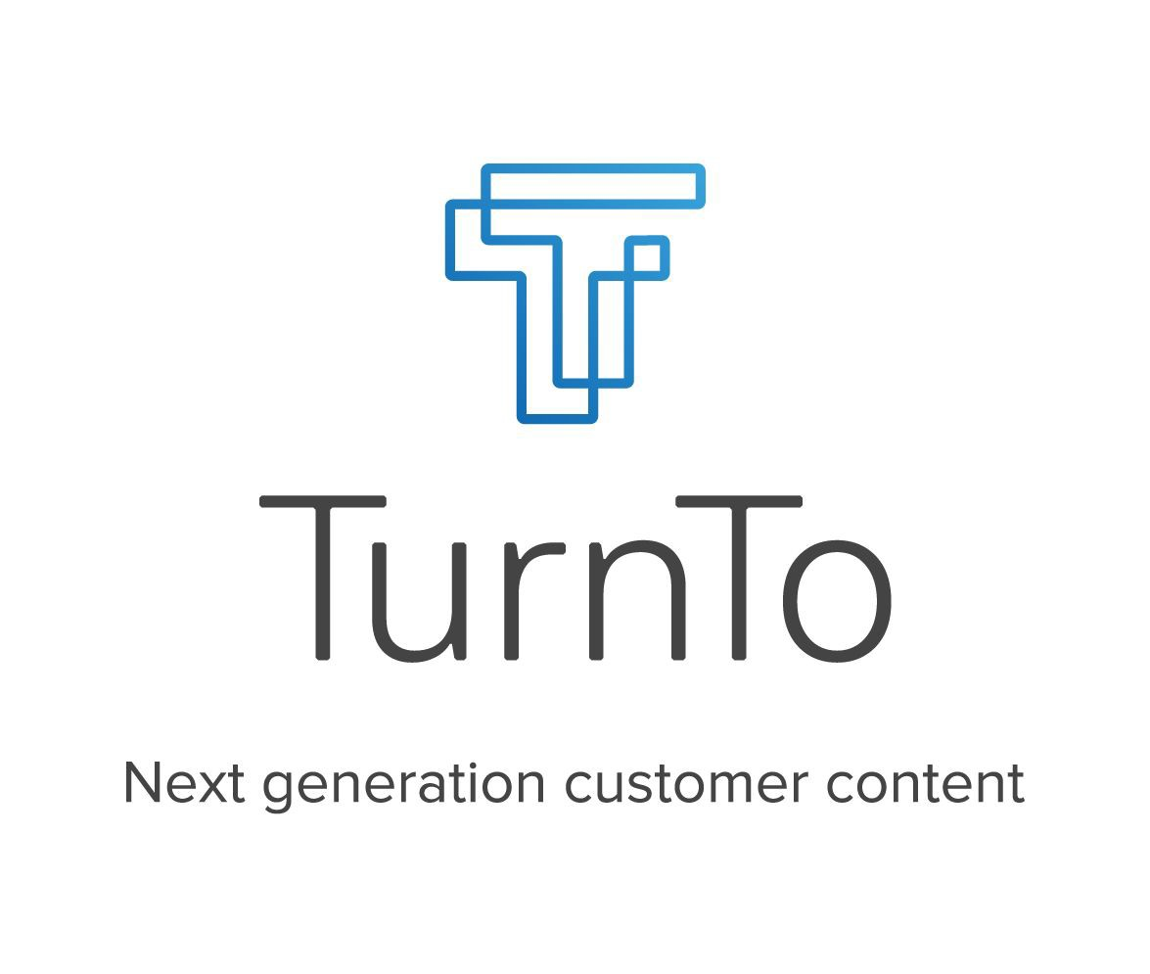

## Table of Contents

Table of Contents 2

General Notes 3

Upgrading 5

## General Notes

**IMPORTANT NOTE: This document contains the general upgrade instructions for upgrading from a legacy version 4.3 or older to SpeedFlex.**

**IMPORTANT NOTE: If you are not upgrading and this is your first time installing the TurnTo cartridges for your client then please refer to the SpeedFlex implementation guides for either Legacy or SFRA.**

#### SpeedFlex Deprecation List

* Mobile Landing Page
* Geo location
* Static embed (all embedding for reviews and Q&A is completed through dynamic embedding)
* Single Sign On
* Site Preference Groups (the following groups are deprecated and removed from the meta data)
  + “TurnTo Checkout Comments”
  + “TurnTo Q&A”
  + “TurnTo Reviews”
  + “TurnTo Visual Content”
* TurnTo General Settings site preference group has been modified
* CSS overwrites
* “default” locale
* Gallery Row Widget

#### SpeedFlexUpgrade List

* All features contained within the TurnTo dashboard
* Dynamic embed so all content matches the TurnTo system
* Star SVGs
* Dynamic Page ID configuration

**Localization**

The only modification required for localization is that the “default” locale has been deprecated so all references to it must be changed to valid locales.

**Export and Import Jobs**

There have been no changes to the export and import jobs, the only difference is that the reviews and UGC imports cannot be used for embedding content through static embed.

## Upgrading

NOTE: Please note that these instructions were designed from upgrading from a non-modified Site Genesis site to a non-modifed SFRA site. They cannot account for customizations to a client’s site.

1. The SpeedFlex core and/or SFRA cartridges will need to replace the current non- SpeedFlex cartridges in your code base.
2. The SpeedFlex core and/or SFRA cartridges will also need to replace the current non- SpeedFlex cartridges in your sites “effective cartridge path”.
3. Import the latest meta data file “TurnToMetadata_v5.xml”.
4. Import the latest schedules data file “TurnToJobSchedules_v5.xml”.
5. The services file is identical to v4.3 so no need to import.
6. Please verify there are no references to the “default” locale. If there are references, please replace with a valid locale.
7. Remove any references to the mobile landing page in Business Manager, which is through “Pipeline URLs” (Merchant Tools -> SEO -> URL Rules -> Pipeline URLs).
8. Domain names are no longer required, which means you won’t have to change or do anything additional.
9. Enable/disable features through the TurnTo dash board, feature enabling is no longer controlled via the installation code.

**NOTE: Feature placement however is controlled via the installation code; see the corresponding SpeedFlex implementation guides for legacy and SFRA for further details**

1. Pages now have dynamic page IDs, which control certain configurations through added attributes.
2. Remove all references to single sign on.

**NOTE: If you are having any trouble upgrading, please refer to the legacy or SFRA SpeedFlex implementation guides.**